Pong: VR

# Game Design Document

# Paul Meyer

# GIMM

# College of Innovation and Design

# Boise State University

## Introduction

Pong: VR is a VR reimagining of Pong. The ball will bounce back and forth between two players increasing in speed until one player can’t keep up and allows the ball to hit their wall. The first player to eleven, loses.

## Description

This is a VR reimagining of the original pong game, and because of that a lot of the game will feel familiar. With the upgrade to a new and trendy Virtual Reality setting the graphics will be updated too. A Sci-Fi light show will flash neon lights as the ball reflects the lights and bounces with flashy particle effects. Synth music will add to the Sci-Fi feel of this classic reimagined. Players will control paddles attached to their hands to block the ball from reaching their end of the court. With the update into three dimensions the players will have to guard an entire plane instead of a single line as the original game had you do.

## Key Features

* Virtual reality orientation and control: The players must learn how the VR tracking software tracks the hand movement of the player and compensate for any shortcomings.
* Competitive Multiplayer: The game is a 1v1 duel that will determine who is the best at being in VR.
* Aggressively surface level aesthetically pleasing laser show like lights will enthrall the player.
* After the core game is completed, small interesting side things might be added, like a   
  Rube Goldberg machine that showcases the Unity Physics Engine.

## Genre

Classic Reskin and extra dimensional update.

Competitive 1v1 multiplayer

## Platform

PC

## Objectives

* Hit the ball into the opponents wall
* Prevent the ball from being hit into your wall

## Mechanics

* Ball bounce mechanic (for walls, and paddles achieved through Unity Bounce Materials)
* Goal Mechanic (for when the ball hits one of the players walls)
* Center obstacle mechanic (a moving wall that obstructs the players ability to shoot the ball directly across to the other player)

## Rules

* When the ball hits a paddle or side wall the ball will bounce with a slightly increasing speed
* If the ball hits a goal wall then the player who the wall does not belong to gets a point.

## Controls

* A paddle will track the players hand
* A trigger will be pulled to start the game.

## Interactive Elements

* Ball: if the ball hits the players paddle it will bounce off of it.

## Physics

* The ball will bounce back and forth with no gravity off of the four side walls and the paddles

## Multiplayer

* The game will have two players, one on each side of the court

## Level Diagram

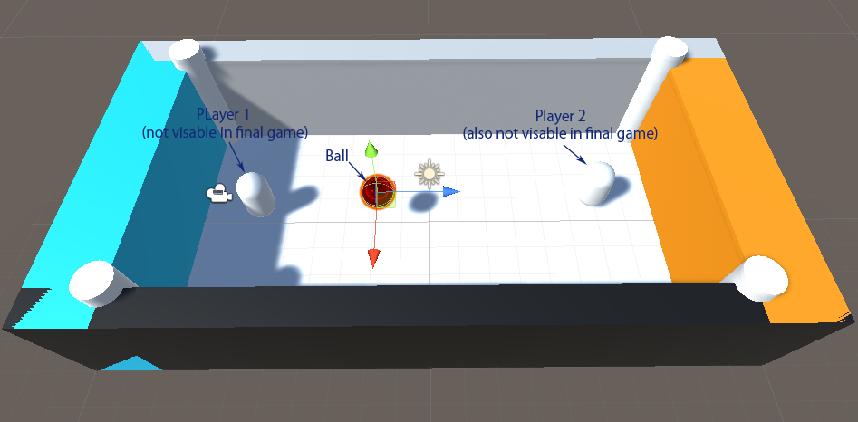

## Graphics Style

* Sci-Fi light show, heavy reliance on Unity’s feature set

## World

* No natural lighting, but intense artificial colored light.
* Visually and audibly noisy
* Intentionally a little overwhelming

## Interface

* Easy button menu (press a button on the controller to launch game)
* The game tracks the controller with no other input

## List of Art Assets

* Ball
* Paddle
* Arena (walls and stuff)
* Lighting Code
* Particle Effects

## Music

* Sci-Fi synth. Unnatural sound.

## World Sounds

* Once again unnatural Sci-Fi
* Over the top synthesized and heavily edited sound effects

## List of Sound Assets

* Wall Bounce Sound
* Paddle Bounce Sound
* Start Sound
* Point Sound
* Victory Sound

## Development Tools

1. Unity
   * Networking: Unity Multiplayer Networking High Level API (HLAPI)
   * Physics: Unity Physics Engine (Bounce Materials)
2. Oculus Tools
   * OVR Player controller